CMC document uploading feature for CCE
- It will be mandatory document.
- It will use standard upload panel that consists of file, issue by, issue date, expiry date. There is no automatically form filling.
- It requires verification from CCE admin team.
- User journey is
  - User update their red-center application.
  - User upload their CMC document into the system using CMC panel in SEP Module.
  - Admin verifies the document and correct it, if need.
  - SCC, CC can show CMC online and offline mode. ;P

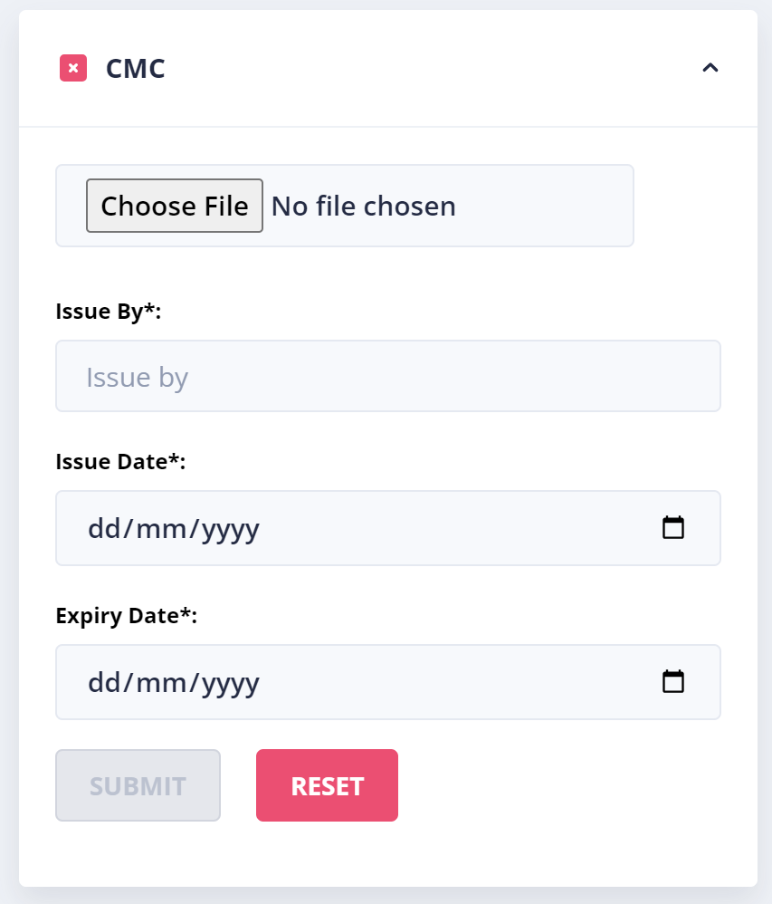
CMC document upload panel in SEP module
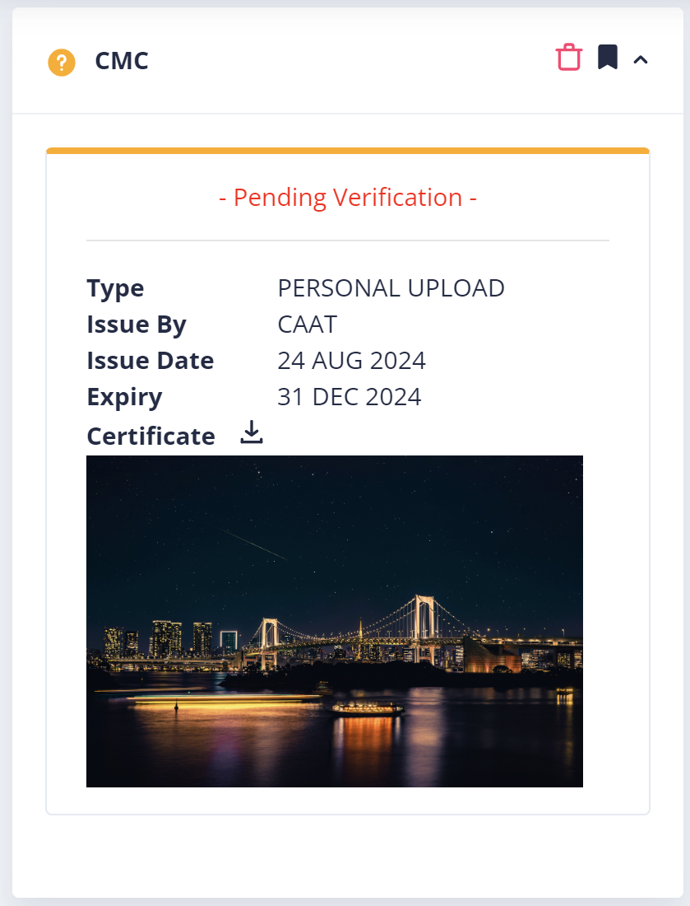
CMC document in pending verification (Before admin verification)
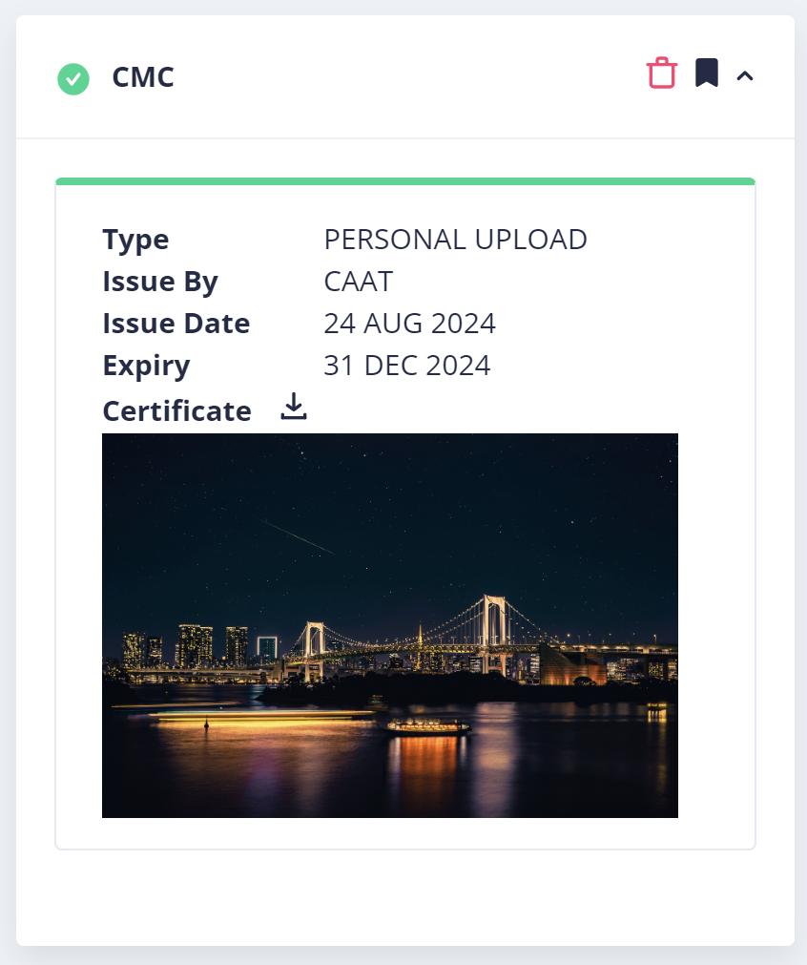
Final CMC document in SEP module
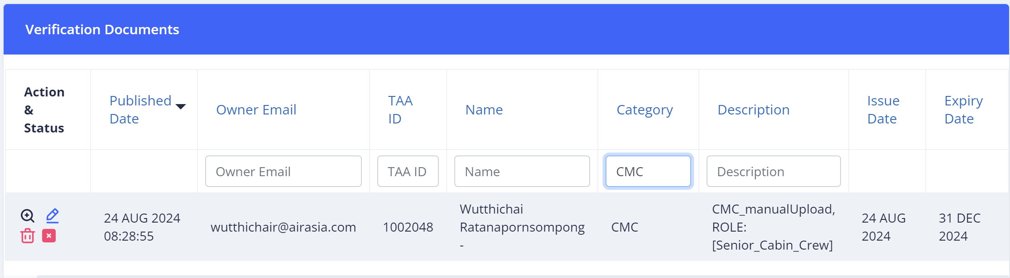
Admin verification dashboard (Category of CMC document is CMC)
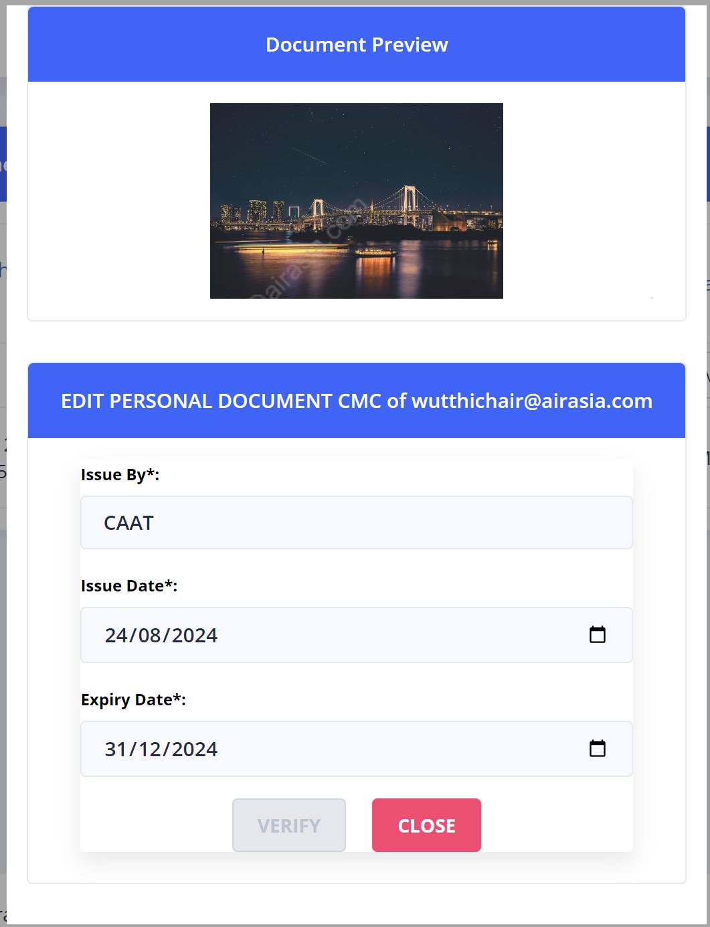
Admin verification panel

